**Design Document for:**

# A Simple Room

**Selective Filtering and You**

“Anyone can overcome it!”™

All work Copyright ©2017 by Stanislav Schaller

Written by Stanislav Schaller

Version # 1.00

Thursday, February 22, 2018Table of Contents

Name of Game Error! Bookmark not defined.

Design History 4

Version 1.00 4

Game Overview 5

Philosophy 5

The Magic and Worth of Small Things 5

Text Over Image 5

Common Questions 5

What is the game? 5

Why create this game? 5

Where does the game take place? 5

What do I control? 5

How many characters do I control? 5

What is the main focus? 6

What’s different? 6

Feature Set 7

General Features 7

Game play 7

The Game World 8

Overview 8

The main character's attention and memory 8

The Room, or the apartment 8

Outside 8

The Physical World 8

Overview 8

Key Locations 9

Travel 9

Weather 9

Time 9

Game Engine 100

Overview 10

Hypertext Driven Interface **Error! Bookmark not defined.**0

Javascript and CSS Enhancement **Error! Bookmark not defined.**0

Game Characters 11

Overview 11

Arthur the fisherman 11

Enemies and Monsters 11

User Interface 12

Overview 12

Musical Scores and Sound Effects 13

Overview 13

Single Player Game 14

Overview 14

Hours of Game-play 14

Victory Conditions 14

# Design History

This is a record of changes to the design. A GDD should be a living document as development tends to change and flesh out a game from idea to realization. Having a history of those changes will help us know why we’ve made the decisions we have made.

## Version 1.00

First foray into a GDD for this undertaking. Fill in:

1. Game Overview
2. Feature Set
3. The Game World
4. The World Layout
5. Game Characters
6. User Interface

# Game Overview

## Philosophy

### The Magic and Worth of Small Things

Every day life can be forgotten easily. A Simple Room will try to explore the point of view of someone who filters most of their life out. This game will try to argue for the magic and worth of small things and moments that culminate in a life.

### Text Over Image

The experience of not paying attention to your surrounding or filtering out repetitive life events works best in the form of textual descriptions rather than images. As the player goes through the game, places and people in game will get more text added to their description as the player’s character becomes more attentive. If this were done with images, there would be gaps that a player may expect would be filled before the point of the game is divulged.

## Common Questions

### What is the game?

A Simple Room is a text adventure game in the style of a choose your own adventure. The player is presented with descriptions of people and areas and will be presented with pre-written choices for the player character to take. The descriptions begin sparse, as though not much is in the game, and the room the player character starts in wants the player character to leave. As the player pushes the character through the sparse world and enounters events and people, the room and all over visited areas and people will have more descriptions and choices added to them. Eventually the player will learn why the room wants them to leave.

### Why create this game?

I’m creating this game because I’m interested in both isolating the feeling of exploration for its own sake and because I feel as though I am so forgetful about my own common life. I love exploration in games and tend to go left when I am supposed to go right. I also feel as though I’m beginning to become more forgetful in my everyday life. A week may go by and I can’t remember anything that really stood out in the week. This game equates momentous living with exploration and a curiosity for life that maybe give a life more meaning.

### Where does the game take place?

The game takes place in a small section of a suburb. The player character spends time in the room, which will be revealed to be their own apartment, and can go explore the town center and the path by the nearby lake.

### What do I control?

The player controls the main character through prewritten choices. The choices expand over time at each location the character can visit.

### How many characters do I control?

There is only one character for the player to control.

### What is the focus?

The focus of the game is to expand the game world and figure out why the room doesn’t want the main character in it.

### What’s different?

Not many text adventure games get made nowadays. Exploration is the point of many other games and can be a pull for players that naturally want to explore game worlds, but there are less games that weave game world exploration with the subjective experience of the main character.

# Feature Set

## General Features

Alient world that becomes more familiar over time

Vague to vivid descriptions

Interesting characters

Pick up and drop at any time

## Gameplay

Textual descriptions and choices

More descriptions over time

More choices over time

Non linear progression

# The Game World

## Overview

The game world is a small section of a town or suburb. The main character’s apartment, the town center around the prominently featured red maple tree, and a bench by a lake popular with the town’s fishermen are the three major locations of the game. The game world strives to not be much different from the real world. What makes the game world interesting is the main character’s relationship to it. The game world doesn’t hold any reason to the main character at the start of the game to be remembered. Places, events, and non-playable characters in the game world will change the main character’s mind over the course of the playthrough.

Though the game world strives to be like the real world, the point is that the world around any person is filled with things worth paying attention to and remembering for their own sake.

## The Main Character’s Attention and Memory

Nothing much stands out to the main character except the most obvious or most used parts of their environment. The room starts off as having not much in it and the main character knows that the room wants them to leave. Outside is only visible a big red maple tree and a bench. As the main character explores these locations they will noticed people and other aspects of the landscape there. The attention will carry over back to the room which will eventually morph into the apartment, and then my apartment.

The main character’s attention and recall serve as the main progress bar of the game’s completion. The player will feel spurred on to play to discover more of the environment, all to figure out why the room doesn’t want them there and possibly how the character became this way.

## The Room, or the Apartment

The Room is the place the main character starts and returns to over the course of the game. The character continually leaves because the room does not want them there. The character soon begins to wonder why the room doesn’t want him there and returns to figure more out.

At the start of the game the room feels sparse, and it becomes clear that the room is just a place the main character goes to sleep and eat takeout food. There’s no feeling of ownership over this space. Over the course of play the main character will soak in more details until the room morphs into an apartment, complete with a kitchen, small living area, balcony, and bedroom. The character’s progress can be tracked through how much of the room the character takes notice of and eventually the ownership the character takes over the apartment. It will become “My Apartment” instead of “The Apartment.”

## Outside

Outside the room is where most of the main character’s growth happens. People and events at both the Red Maple Town Center and the Bench Beside Lake Threlkeld help the main character notice and retain more about their own world. Arthur the fisherman can be found at the bench and is the main character’s link to the past and presentness. Chris the coworker is found at the town center working the same job as the main character and is the link to the character’s anticipation of the future.

## The Physical World

### Overview

The game takes place in a subsection of a small town or suburb. The main character’s apartment, known as The Room, looks out over the town center. The Red Maple Town Center is a short walk from The Room and features a red maple in the center, around which is a shopping plaza. The main character works at a pop-up shop known to the locals as the Red Maple. A path leads away from the plaza and down to the nearby lake, where the local fisherman like to sit on benches and enjoy the air.

### Key Locations

The Room - The room is the main character’s apartment. It feels sparse at first and is typical of a person who comes home mostly to eat, zone out, and sleep. Points of interest in the first phase of the game are the couch and tv, the desk and laptop, and the bed. The desk and bed are in the bedroom, and the living room just outside the bedroom is where the tv lives. The room expands from the living room out to a kitchen on one side and a door to the balcony on the other side.

The couch and tv features a coffee table. The table tends to have discarded take out containers on it, dirtied cups, and half read magazines. The desk is small and well used. A laptop lives here, but there’s also a few journals, pens, and pencils in one of the desk’s drawers. There’s a bookshelf to the left of the desk, sparsely filled with books. Titles range from young adult supernatural thrillers to collections of photography.

The bed has a side table. The sheets should probably be changed a little more often than they are.

The kitchen has a decent counter top, sink, and fridge. The fridge is mostly empty, containing some condiments and food that should probably be thrown out. In the corner, there are a few cook books, but they look like they haven’t been touched in a while. The balcony looks out over the town center, the red maple at the town center visible not far below. There’s a wooden rocking chair here.

The Red Maple at the Town Center - The Red Maple is a red maple at the center of a paved circle at the town center. There are stores around the maple, including a pop-up location where the main character and Chris work. The pop up tends to be an ice cream shop in the summer, a doughnut and hot chocolate joint in the winter, with spring and fall being wild cards. Recent notables for the wild card seasons are a jewelry shop, a flea market, and a traveling used book shop.

Restaurants around the maple tend to have open air sections with tents for weather. The days are filled with passersby and families playing around the maple and shopping, and the nights, especially warm ones, feature lively music and bar goers. The center is a short, paved walk away from the room, and an alley between some shops around the center leads to a dirt path that goes to the bench at the lakeside.

The Bench at the Lakeside - This is the bench that Sammy sits at, fishing. It sits off path that circles the lake the bench faces. Behind the bench is a bit of a hill. The view from the bench is tranquil. The walk up to the bench is cleared of the trees that provide cover for the path leading to and away from this spot. A few homes can be seen across the lake, and on warm days there are swimmers and boaters on the lake. In winter, it freezes, but the weather doesn’t get cold enough to freeze the lake deeply. Sammy avoids the winter.

### Travel

The main character moves around the world by walking. All locations in the game are easily accessible by foot and the transitions are implied when selecting a location to visit.

### Weather

Certain times of the year will feature different weather. Fall is cool and has intermittent showers. Winter lacks snow but the lake does freeze, meaning Arthur won’t be found at the bench near the lakeside. Spring features more rain than fall with days ranging from wet summer heat to light jacket temperatures. Summer is hot and has intermittent thunderstorms, though it’s mostly a wet heat.

### Time

Time passes quickly at the start of the game. It may take only three forays out of the room for the season to change from summer to fall. As the main character takes the time to notice the world around them, the changing of the seasons slows down, and time passes at a week at a time to eventually a day at a time per leave the room and come back to it cycle.

## Game Engine

### Overview

This game will use the Twine 2 engine, originally created by Chris Kilmas and now maintained in multiple open source projects. Twine is an HTML based non-linear interactive story builder that the user interacts with mostly through the GUI. The engine supports javascript and css for more advanced users.

### Hypertext Driven Interface

Hypertext links move the player between scenes. Description is offered above and hypertext choices are shown below. Navigation is simple and variable can be assigned and saved behind the scenes per click. The engine also has built in macros to handle basic tasks such as saving the player’s game, game state and history,

### Javascript and CSS Enhancement

Twine 2 uses html for its backbone and an advanced user can use javascript for event-based execution and css for styling beyond what comes out of box.

# Game Characters

## Overview

The main character is the character the player controls. They start the game filtering our most of their own daily life. There are two non-player characters, Arthur the fisherman and Chris the coworker.

## Arthur the Fisherman

Arthur is an avid fisherman that the character meets at the bench at the lakeside. He speaks with a measured, slow cadence as if every word is considered before he utters it. He features salt and pepper hair that is kept neat in a way that invokes former military, though it’s somewhat longer than military code would allow. He wears comfortable clothing, always with a puffy vest over a long shirt regardless of the season. He has his tackle box next to him and his fishing rod propped up in sight in front of him.

Arthur talks to the character about enjoying the air and taking the time to watch the lake. He alternates between talking about what he sees, feels, and enjoys in the moment and memories of his past. Speaking of his past gives the impression of a life long-lived and full of formative events that Arthur consistently under explains. The time he was trapped in a port on his merchant marine boat as fresh enlisted man was just that, a time.

Arthur is the main character’s filter for other events at the tree and room. The main character can always go to Arthur for context on how the experience of now and the past are connected and worthwhile.

## Chris the Coworker

Chris has been working at the Red Maple pop-up store front for as long as the main character can remember. Chris has managed to keep getting rehired by every different store that pops up in the Red Maple location and generally enjoys the change of pace when a new store stands up. Chris’s favorite is the ice cream pop-up in summer because that’s when the location is the liveliest and ice cream tastes good. Chris works with the main character and has been casually trying to get the main character to come hang out with some other local restaurant and retail workers after the shop closes but has so far been unsuccessful.

Chris is a late game opportunity to be in the moment for main character. Chris is most comfortable being around people and seeks environments that provide that stimulation. Chris remembers names and details about people effortlessly. The main character is Chris’s biggest mystery, as they’ve been working together at this pop-up for a while and Chris hasn’t been able to get the main character to open up about much of anything.

Chris loves to cook. If Chris doesn’t have some sort of social function, then cooking is the next best thing.

# User Interface

## Overview

The game has descriptions towards the top of the screen and hyperlinks below that describe the choices available to the player. Screenshots below show the simple ui approach.

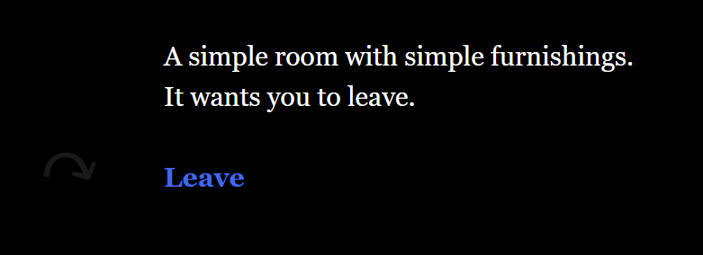

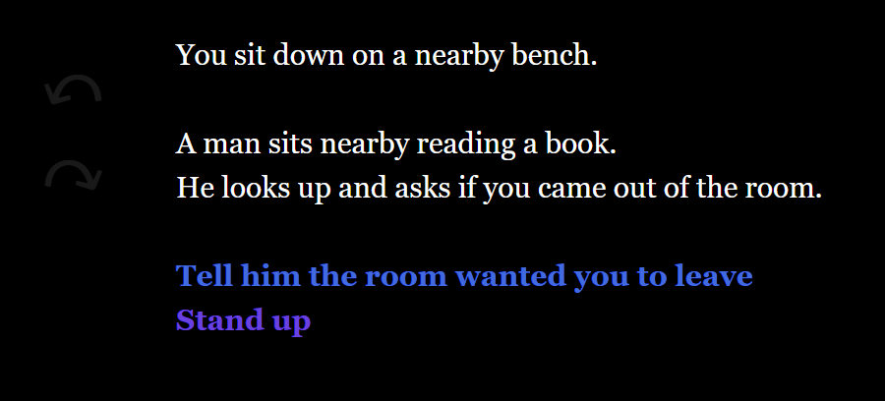

# Musical Scores and Sound Effects

## Overview

There are currently no plans for music or sound effects, as Twine 2 does not support embedded multimedia. Research shows it may be possible to link to music via dropbox or similar persistent storage.

# Single-Player Game

## Overview

The player will guide the main character through the story. The player will read descriptions, move to different locations, and make a series of choices that results in expanded descriptions and choices for the player to take. The player will try to reveal why the room doesn’t them there, and for the joy of exploration.

## Hours of Gameplay

The game will take around two hours to complete.

## Victory Conditions

The player beats the game when they reach the end of the story.